Vidhya.R
192572153
SIMATS ENGINEERING
ASSESSMENT TOOL 6

COURSE NAME: Artificial Intelligence COURSE CODE: CSA1715
COURSE OUTCOME COVERED

CO2: Experiment search and game-solving techniques such as Greedy Search, A*, CSP, Minimax, and Alpha-Beta pruning with heuristic functions for solving complex AI problems efficiently. (BL3)
Assessment Tool Weightage: 40%

Duration: 1 Hour
QUESTIONS: 3 Total Marks:30

Annexure A
Try Run Evaluation
Code of Conduct:
I Vidhya.R(192572153)(Name / Reg No) certify that this submission is my original work and that I have adhered to the guidelines specified for this assessment.I understand that any violation of academic integrity rules will result in disciplinary action.
Signature of the student:
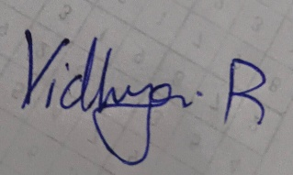

Annexure A

Dry Run Evaluation
1. Question 1 – Breadth-First Search (BFS)
Consider the following graph: A
/ \
B C
/ \ / \
D E F G
Task: Starting from node A, perform a Breadth-First Search (BFS). Complete the following table.
Iteration | Queue | Visited Node
1
2
3
4
5
6
7
Questions:
- Write the BFS traversal order.
- Show the queue contents after each iteration.
2. Depth-First Search (DFS) Using the same graph,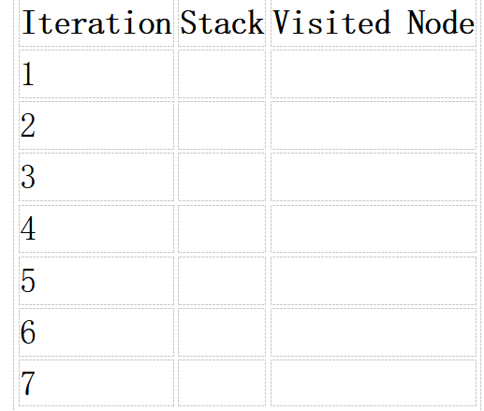
A
/ \
B C
/ \ / \
D E F G
Perform Depth-First Search (DFS) starting from A.
Complete the table.
- Initial State :
1 3 6
5 0 2
4 7 8

Goal State :
1 2 3
4 5 6
7 8 0
Task
Trace Breadth-First Search (BFS) until the goal state is reached.
Fill in the table.
Iteration | Current State | Queue Before Expansion | Queue After Expansion
1
2
3
4
5
Questions
- Which node is expanded in each iteration?
- How many states are generated in total?
- Write the complete solution path from the initial state to the goal state.
- Why does BFS always find the shortest solution in an unweighted 8-puzzle problem?
RUBRICS FOR CALCULATION

Criteria | Weightage (%) | Level 4 – Exemplary (4) | Level 3 – Proficient (3) | Level 2 – Developing (2) | Level 1 – Beginning (1)
Understanding of Search Problem | 20 | Clearly understands the search problem, initial state, goal state, and search strategy. | Understands the problem with minor misunderstandings. | Demonstrates partial understanding of the search problem. | Shows little or no understanding of the search problem.
State Expansion and Dry Run Execution | 30 | Correctly traces every iteration, expands nodes accurately, and maintains the Queue/Stack/Priority Queue without errors. | Performs most iterations correctly with minor mistakes in state expansion or data structure updates. | Performs only some iterations correctly; several errors in tracing or node expansion. | Unable to correctly perform the dry run or expand states.
Application of Search Algorithm | 20 | Applies the selected algorithm (BFS/DFS/UCS) correctly, following all algorithmic rules. | Applies the algorithm correctly with a few procedural errors. | Applies only basic algorithm steps with noticeable mistakes. | Fails to apply the correct search algorithm.
Accuracy of Solution Path | 20 | Identifies the correct traversal order/solution path and goal state with proper justification. | Solution path is mostly correct with minor errors. | Partially correct solution path; goal may not be reached correctly. | Incorrect or incomplete solution path.
Presentation and Logical Reasoning | 10 | Queue/Stack/Priority Queue updates, state diagrams, and explanations are neat, organized, and logically presented. | Presentation is clear with minor organizational issues. | Limited explanation and organization; reasoning is partially clear. | Poor presentation with unclear or missing reasoning.

Criteria | Weightage | Q1 (10) | Q2 (10) | Q3 (10) | Total Marks (30)
Understanding of Problem Context | 20% (2) | /2 | /2 | /2 | /6
Application of Concepts | 30% (3) | /3 | /3 | /3 | /9
Problem-Solving Approach | 20% (2) | /2 | /2 | /2 | /6
Accuracy of Solution | 20% (2) | /2 | /2 | /2 | /6
Clarity | 10% (1) | /1 | /1 | /1 | /3
Total per Question | 10 Marks | /10 | /10 | /10 | /30

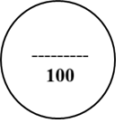

1. Breadth-First Search (BFS)
Given graph
A
/ \
B C
/ \ / \
D E F G
BFS means Breadth-First Search.
It visits nodes level by level.
Level 0 → A
Level 1 → B, C
Level 2 → D, E, F, G
Step 1: Start from A
Initially:
Queue = [A]
Visited = [ ]
Remove A from the queue and visit it.
A has two children: B and C.
Queue = [B, C]
Visited = [A]
Step 2: Visit B
Remove B.
B has children D and E.
Add them to the queue.
Queue = [C, D, E]
Visited = [A, B]
Step 3: Visit C
Remove C.
C has children F and G.
Queue = [D, E, F, G]
Visited = [A, B, C]
Step 4: Visit D
D has no children.
Queue = [E, F, G]
Visited = [A, B, C, D]
Step 5: Visit E
E has no children.
Queue = [F, G]
Visited = [A, B, C, D, E]
Step 6: Visit F
F has no children.
Queue = [G]
Visited = [A, B, C, D, E, F]
Step 7: Visit G
G has no children.
Queue = [ ]
Visited = [A, B, C, D, E, F, G]
BFS Traversal:
A → B → C → D → E → F → G

2. Depth-First Search (DFS)
Same graph:
A
/ \
B C
/ \ / \
D E F G
DFS means Depth-First Search.
It goes as deep as possible first, then comes back and explores the next branch.
Step 1: Start at A
Stack = [A]
Visited = [ ]
Pop A.
Visited = A
Push its children.
Stack = [C, B]
B is on top, so B is visited next.
Step 2: Visit B
B has children D and E.
Push them.
Stack = [C, E, D]
Visited = [A, B]
D is on top.
Step 3: Visit D
D has no children.
Stack = [C, E]
Visited = [A, B, D]
Step 4: Visit E
E has no children.
Stack = [C]
Visited = [A, B, D, E]
Step 5: Visit C
C has children F and G.
Stack = [G, F]
Visited = [A, B, D, E, C]
Step 6: Visit F
Stack = [G]
Visited = [A, B, D, E, C, F]
Step 7: Visit G
Stack = [ ]
Visited = [A, B, D, E, C, F, G]
DFS Traversal:
A → B → D → E → C → F → G
Question 3 – 8-Puzzle BFS again, clearly and step-by-step.
Given Initial State
1 3 6
5 0 2
4 7 8
0 = blank space.
Goal State
1 2 3
4 5 6
7 8 0
We need to use BFS (Breadth-First Search).
Step 1 – Initial State
1 3 6
5 0 2
4 7 8
The blank 0 can move:
Up → 0 swaps with 3
Down → 0 swaps with 7
Left → 0 swaps with 5
Right → 0 swaps with 2
So BFS generates the possible states.
Step 2 – One valid shortest path
A shortest path to the goal is:
Initial
1 3 6
5 0 2
4 7 8
Move 1 – Blank moves RIGHT
1 3 6
5 2 0
4 7 8
Move 2 – Blank moves UP
1 3 0
5 2 6
4 7 8
Move 3 – Blank moves LEFT
1 0 3
5 2 6
4 7 8
Move 4 – Blank moves DOWN
1 2 3
5 0 6
4 7 8
Move 5 – Blank moves LEFT
1 2 3
0 5 6
4 7 8
Move 6 – Blank moves DOWN
1 2 3
4 5 6
0 7 8
Move 7 – Blank moves RIGHT
1 2 3
4 5 6
7 0 8
Move 8 – Blank moves RIGHT
1 2 3
4 5 6
7 8 0
Goal reached in 8 moves.
Complete solution path
Write this in your answer:
1 3 6 1 3 6 1 3 0
5 0 2 → 5 2 0 → 5 2 6
4 7 8 4 7 8 4 7 8

↓

1 0 3 1 2 3 1 2 3
5 2 6 → 5 0 6 → 0 5 6
4 7 8 4 7 8 4 7 8

↓

1 2 3 1 2 3 1 2 3
4 5 6 → 4 5 6 → 4 5 6
0 7 8 7 0 8 7 8 0
BFS solution path:
Initial → R → U → L → D → L → D → R → R → Goal
Total = 8 moves.
For the 4 questions below it:
1. Which state is expanded in each iteration?
The state at the front of the BFS queue is expanded in each iteration.
2. How many states are generated in total?
The solution path contains 9 states including the initial and goal states. BFS itself may generate additional states while searching.
3. Complete solution path:
Initial → R → U → L → D → L → D → R → R → Goal
4. Why does BFS find the shortest solution?
Because BFS explores states level by level. Since every puzzle move has the same cost, the first goal found is reached using the minimum number of moves.

